**RAJAGIRI SCHOOL OF ENGINEERING & TECHNOLOGY (AUTONOMOUS)**

**DEPARTMENT OF INFORMATION TECHNOLOGY**

**Computer Science & Business Systems**

**101009/IT602F MODERN WEB APPLICATIONS LAB**

**SEMESTER 6**

**(Feb 2024-June 2024)**

# WEBSITE USING HTML (week 1)

Create a website that demonstrates the usage of the following HTML tags:

·Headings

·Paragraphs

·Image

·Anchor

·Table tags

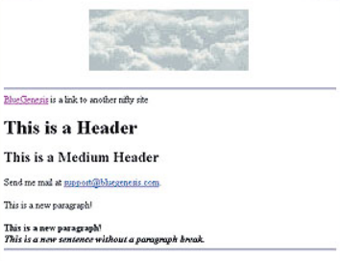

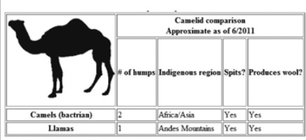

# WEBSITE USING HTML AND CSS (demonstrate the usage of inline, internal and external style sheet using CSS) (week 2)

Develop a website for Online Bus Ticket Booking having pages:

* 1. Home Page:
     + Navbar
     + Banner image
     + Contents
     + Footer
  2. Ticket Booking
     + Book Ticket
     + Booking Details
  3. About Us

1. Develop a **RESPONSIVE WEBSITE WITH BOOTSTRAP** for Online Bus Ticket Booking. (Week3)

# JAVASCRIPT ARRAY, OBJECT AND FUNCTIONS (Week 4)

* 1. Write a Javascript program to find the sum of array and to sort a list of elements using Bubble Sort elements using function(use alert to print the output)

b) Write a Javascript program to calculate grades of students and average grade of a class(use prompt to get input, use document.write() to displays the output)

# FORM VALIDATION USING JAVASCRIPT (Week 5)

Write the client side scripts for Validating HTML Registration (Form Validation) Using JavaScript.

# JavaScript Form Validation using sample registration form

# DOM & EVENT HANDLING (Week 6)

* 1. Write a JS program to find the sum of two number in the button click event.
  2. Create a button named ‘change color’ and change its foreground color to red when mouse over and its back ground color changes to green when mouse out of Button .Use DOM Event listener property.

# AJAX with HTML, XML and JSON data(Week 7)

Write a program using AJAX to retrieve Book title, Author and Price with HTML, XML and JSON data

# JQuey (Week 8)

Implement JQuery inserting elements (.before(),.after(), .prepend() and .append()).

1. **AngularJS (Week 9)**

Create a simple AngularJS application that displays a list of items fetched from a predefined array in the controller. Include features like filtering and sorting.

1. Develop a web site with HTML, CSS, Javascript/JQuery, Node JS and any db (Groupwise microproject)

# Student Management System

* 1. **Library Management System**

# Hospital Management System

* 1. **Supply Chain Management System etc**

Prepared By:

Dr. Nikhila T Bhuvan (Lab in-Charge)

Verified By:

Mr.Mathews Abraham

Ms.Divya James

Ms. Thasnim K M

Approved By:

Dr.Neeba E A (HOD-IT)